**Test plan**

# Login testing part:

Case 1: do not enter any data into text fields and click on login

Case 2: enter incorrect password

Case 3: enter correct name and password

# New guest testing part

Case 4: enter incorrect first name in domestic guest entry

Case 5: do not entry any data into text fields and click on save in international guest entry

Case 6: enter correct data into all text field

# Search testing part

Case 7: enter incorrect name

Case 8: enter correct id number

# Delete testing part

Case 9: enter correct id number

Case 10: enter incorrect name

# Display testing part

Case 11: display list of domestic guests

Case 12: display list of speaker

# Update testing part

Case 13: update information of international guests

Case 14: try to change ID number

# Report testing part

Case 15: make the report

# Test table

| **Test**  **Case** | **Steps** | **Test data** | **Expected result** | **Actual result** | **Screenshot** |
| --- | --- | --- | --- | --- | --- |
| 1 | 1.Run the program.  2.click on login | No data | POP up message “Incorrect name” | POP up message “Incorrect name” | 1.1 |
| 2 | 1.Run the program.  2.enter admin 123  3.click on login | Name: admin  Password: 123 | POP up message “Incorrect password” | POP up message “Incorrect password” | 1.2 |
| 3 | 1.Run the program.  2.enter admin, admin  3.click on login | Name: admin  Password: admin | POP up message “Successfully logged in” | POP up message “Successfully logged in” | 1.3 |
| 4 | 1.Run the program.  2.enter admin, admin  3.click on login  4.click on new guest – add domestic  5. enter data in text field  6. click on save | First name: df 123 | POP up error message “First name must contain only characters, and must contain 2 or more characters” | POP up error message “First name must contain only characters, and must contain 2 or more characters” | 2.1 |
| 5 | 1.Run the program.  2.enter admin, admin  3.click on login  4.click on new guest – add international  5. click on save | No data | POP up error message “First name must contain only characters, and must contain 2 or more characters” | POP up error message “First name must contain only characters, and must contain 2 or more characters” | 2.2 |
| 6 | 1.Run the program.  2.enter admin, admin  3.click on login  4.click on new guest – add domestic  5. click on speaker  6. enter data in text field  7. click on save | First name:  Boris  Second name: Avdeev  Affiliation:  Unitec  Position:  Student  Email:  [cdne47@bk.ru](mailto:cdne47@bk.ru)  Street:  12 sup street Auckland 1234  Number:  +644268310  Attend:  Yes  Topic of speech:  Java 8 | POP up message “Speaker added successfully” | POP up message “ Speaker add successfully” | 2.3 |
| 7 | 1.Run the program.  2.enter admin, admin  3.click on login  4. click on search option search domestic guest  5. enter data in text field  6. click on search | Name: name | Pop up message ”Domestic guest could not be found” | Pop up message ”Domestic guest could not be found” | 3.1 |
| 8 | 1.Run the program.  2.enter admin, admin  3.click on login  4. click on search option search speaker  5. enter data in text field  6. click on search | 27953 | The program will show speaker | The program will show speaker | 3.2 |
| 9 | 1.Run the program.  2.enter admin, admin  3.click on login  4.click on delete options  5. click on delete guest  6. enter data in text field  7. click on delete | 3457 | Pop up message ”Domestic guest could not be found” | Pop up message ”Domestic guest could not be found” | 4.1 |
| 10 | 1.Run the program.  2.enter admin, admin  3.click on login  4.click on delete options  5. click on delete guest  6. enter data in text field  7. click on delete | Boris | Pop up message “Domestic guest deleted” | Pop up message “Domestic guest deleted” | 4.2 |
| 11 | 1.Run the program.  2.enter admin, admin  3.click on login  4.click on display and options  5. click on display domestic guests | No data | The program will show list of domestic guests | The program will show list of domestic guests | 5.1 |
| 12 | 1.Run the program.  2.enter admin, admin  3.click on login  4.click on display and options  5. click on display speaker | No data | The program will show list of  speakers | The program will show list of  speakers | 5.2 |
| 13 | 1.Run the program.  2.enter admin, admin  3.click on login  4.click on display and options  5. click on display international guest  6.edit cells  7.click on update | Change name from Leo MC  To  Hummer MC | POP up message “Updated” | POP up message “Updated” | Before update  6.1  Update  6.2  After deleted  6.3 |
| 14 | 1.Run the program.  2.enter admin, admin  3.click on login  4.click on display and options  5. click on display international guest  6.try to edit id number cell  7.click on update | No data | ID number cell wouldn’t be selected and edited | ID number cell can be selected and deleted | - |
| 15 | 1.Run the program.  2.enter admin, admin  3.click on login  4.click on report  5. click on make report | No data | The program will show the report | The program show the report | 7.1 |

# Appendix

**Screenshot 1.1**

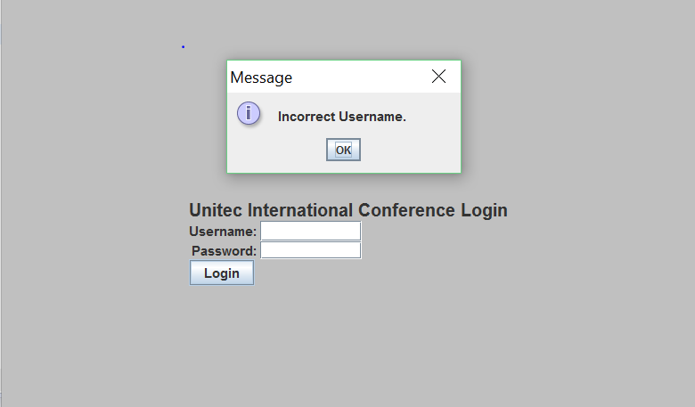

Screenshot 1.2

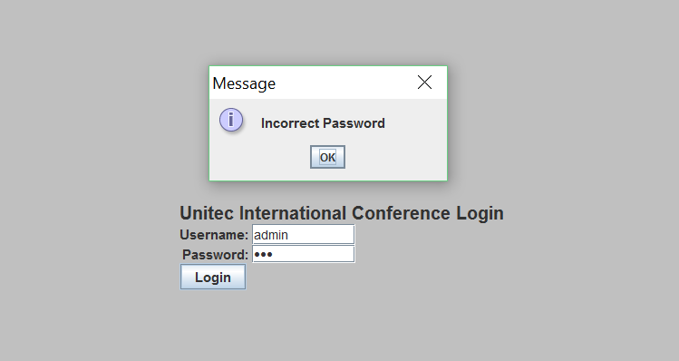

Screenshot 1.3

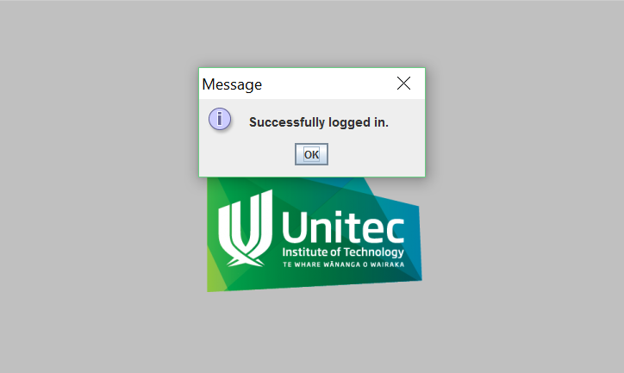

Screenshot 2.1

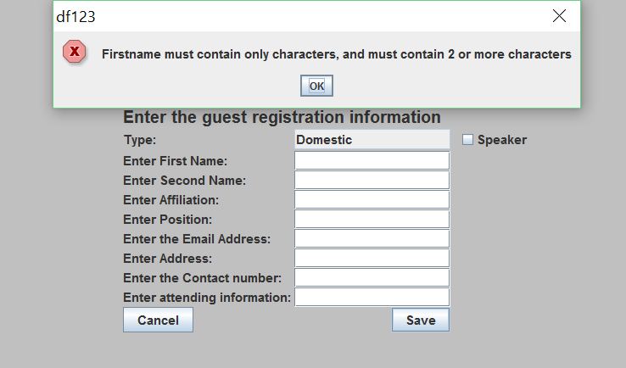

Screenshot 2.2

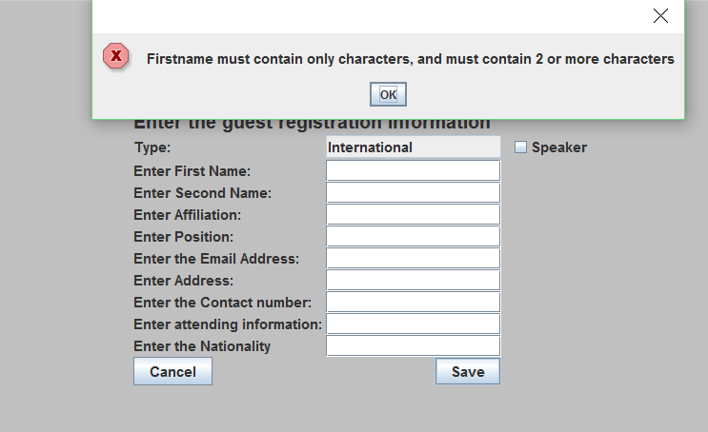

Screenshot 2.3

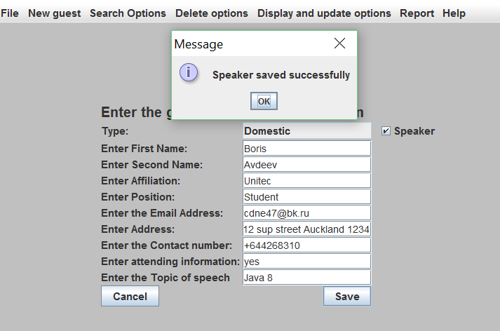

Screenshot 3.1

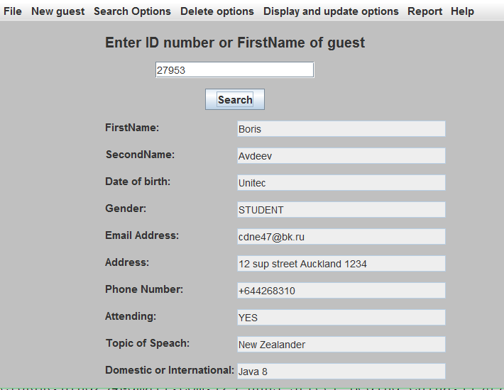

Screenshot 3.2

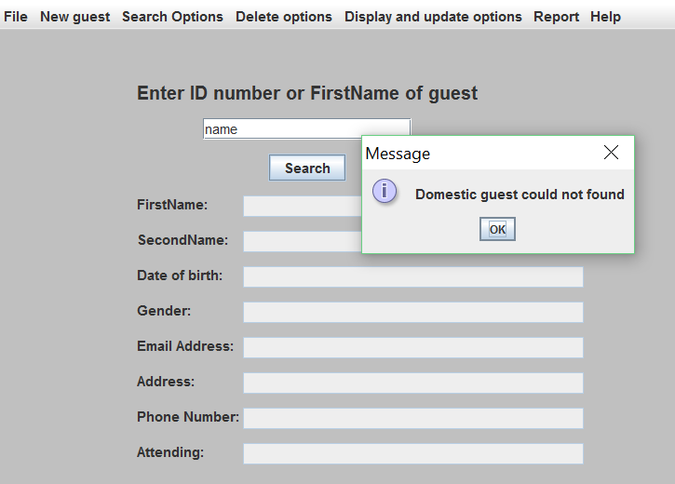

Screenshot 4.1

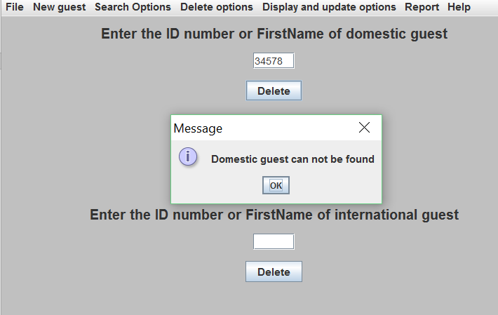

Screenshot 4.2



Screenshot 5.1

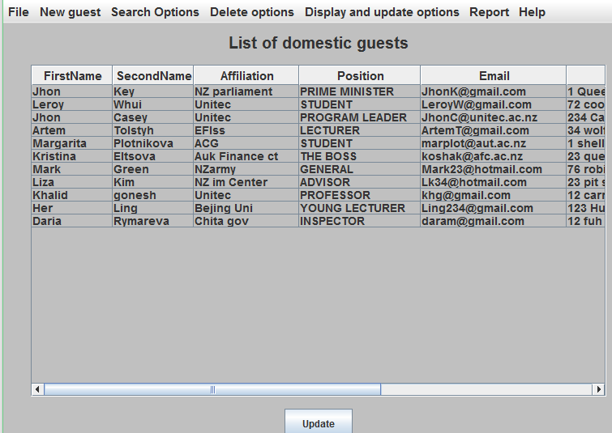

Screenshot 5.2

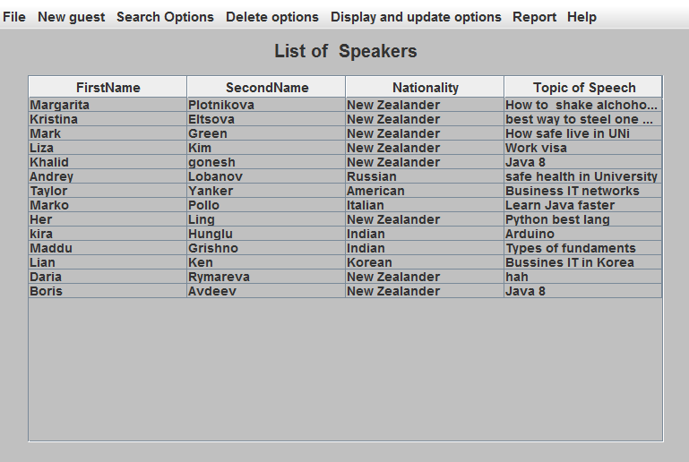

Screenshot 6.1

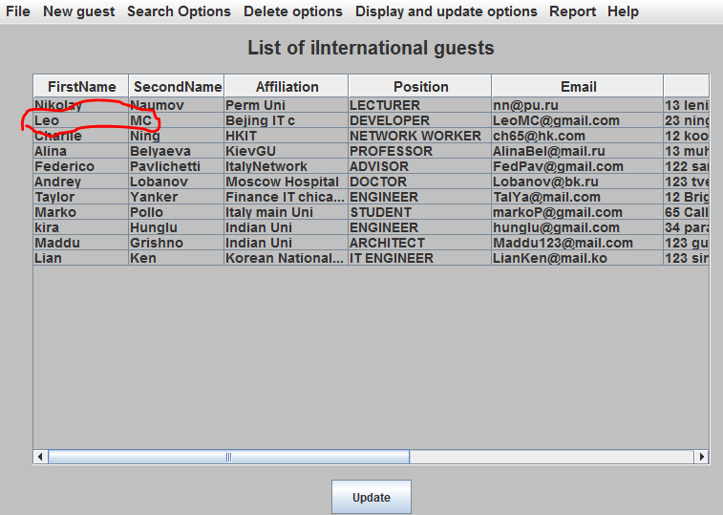

Screenshot 6.2

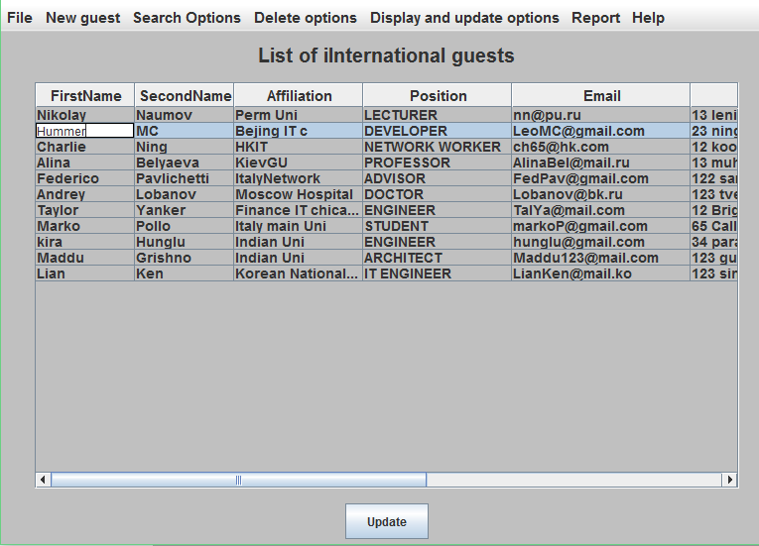

Screenshot 6.3

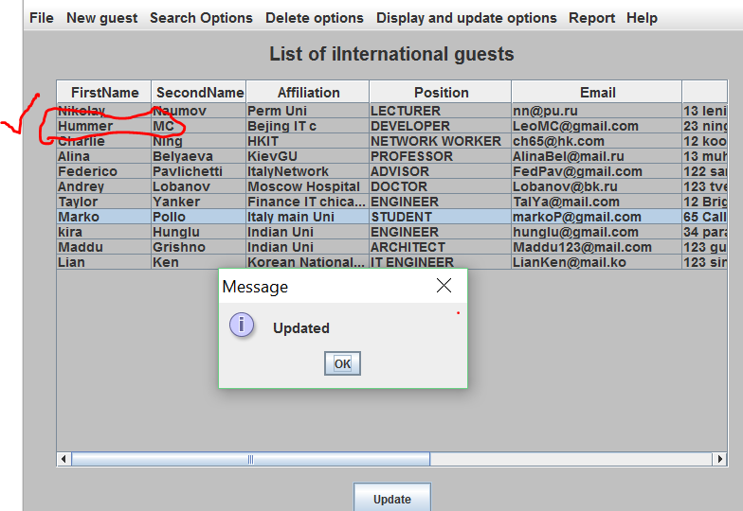

Screenshot 7.1

